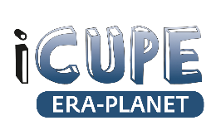
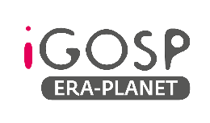
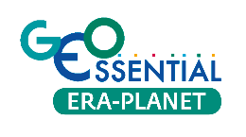
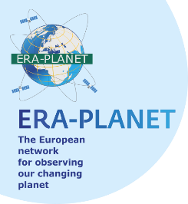

GEO 2021 Virtual Symposium
Session Proposal Form

Session Title: A contribution from ERA-PLANET to demonstrate Earth Observation operational services for shaping cost-effective strategies to support policy makers and stakeholders.

Session Type: X Parallel Session

Session Date: - 24 June 13:00-14:00

Session Description
The European network for observing our changing planet (ERA-PLANET, www.era-planet.eu) is a 6-yr H2020 program (an Era-NET co-fund) aimed to foster a better cross- and interconnected national Earth Observation systems ensuring a more efficient access and exploitation of information. ERA-PLANET has developed a Transnational Environmental Observation System in Support of European & International Policies through the Integration of in-situ and satellite monitoring data under different Strands. The activities have been designed within four clustered thematic projects (Thematic Strands), namely SMURBS, GEO Essential, iGOSP and iCUPE, which are:
Strand 1 (SMURBS) – Focused on smart cities and resilient societies addressing issues such as urban growth, air quality, migration and health.
Strand 2 (GEO Essential) – Focused on the management of environmental resources including preservation of biodiversity.
Strand 3 (iGOSP) – Aimed to develop global observing systems for toxic and persistent pollutants and operational knowledge hubs (interoperable systems) that policy makers and stakeholders may adopt to evaluate different cost-effective strategies that may be implemented at national and international scales to achieve the goals of EU directives and international conventions.
Strand 4 (iCUPE) – Focused on polar areas and natural resources, iCUPE is aimed to develop policy-oriented operational systems for highly climate-sensitive regions including the evaluation of consequences of energy resource exploitations policy, the impact of long-range transport of air pollutants and their atmospheric deposition to the Arctic, air-surface exchange mechanisms, and environmental pressure from increasing anthropogenic pressure.
ERA-PLANET though its SMURBS and iGOSP projects is contributing to the E-shape project (https://e-shape.eu) which is aimed to power user-oriented applications that stakeholders and policy makers may use. Within the E-Shape project the contribution from SMURBS and iGOSP is focused on a dedicated Showcase on Health Surveillance and specifically through three pilots, EO-based surveillance of mercury pollution, EO-based surveillance of POPs pollution and EO-based pollution-health risks profiling in the urban environment, which are addressed to provide (by the end of E-Shape project) mature market-oriented applications for co-designing policy-oriented socio-economic scenarios.
In this session, we will present the outcome of the ERA-PLANET projects as a contribution to GEO and to the implementation of the UN Agenda 2030.

Speaker(s) and Moderator(s)
(Please include the full name and email address of each speaker and the moderator, as well as the titles of short presentations, if applicable. For Parallel Sessions, please allow at least 30 minutes for discussion).
Speakers (6 min each):
- The ERA-PLANET approach to support GEO and its legacy for Horizon Europe
by Nicola Pirrone, nicola.pirrone@iia.cnr.it

- Resilient and sustainable cities and human settlements
by Evangelos Gerasopoulos egera@noa.gr

- Extracting some SDG Indicators from measurements of Essential Variables
by Anthony Lehmann Anthony.Lehmann@unige.ch

- Operational user-oriented systems to support Parties in the implementation of the international conventions on Hg and POPs
by Nicola Pirrone, nicola.pirrone@iia.cnr.it

- Impact of long-range transport of air pollutants on Polar Environments
by Tuukka Petaja tuukka.petaja@helsinki.fi

Discussion open to all participants (30 min)
Moderator:
Stefano Nativi, stefano.nativi@ec.europa.eu

GEO Work Programme Activities Involved
GOS⁴M Flagship, GOS⁴POPs Initiative

Session Contact(s)
- Nicola Pirrone, ERA-PLANET Coordinator, nicola.pirrone@iia.cnr.it

